
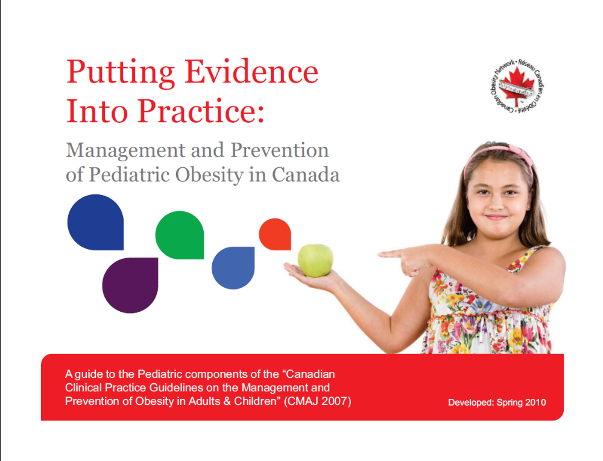

Resource Guide

Develop Spring 2010


Introduction
This resource guide is to be used in conjunction with the CPG dissemination slides. This resources guide has been organized by slide number in relation to the dissemination slides as published on the CON website. Slides not listed do not have any resources associated with them.

Slide 9:
Childhood Obesity in Canadian Children
Comparing Childhood obesity rates in Canada in the years 1979 and 2004 (graph):
Shields M. Measured obesity: overweight Canadian children and adolescents. Nutrition: findings from the Canadian Community Health Survey. 2005; http://www.statcan.ca/english/research/82-620-MIE/2005001/pdf/cobesity.pdf [accessed 9 Jan 2007].

Slide 11:
Obesity and Children’s Health
Ebbeling C.B., Pawlak, D.B., & Ludwig, D.S., 2002. Childhood obesity: public-health crisis, common sense cure. Lancet, 360(9331), pp.473-482.

Slide 14:
Recommendation: Role of Health Professionals
CPG recommendation: Page 52
Available at http://www.cmaj.ca/cgi/data/176/8/S1/DC1/1

Slides 24 & 25:
Recommendation: BMI Screening
CPG recommendation: Page 31
Available at http://www.cmaj.ca/cgi/data/176/8/S1/DC1/1

Center for Disease Control and Prevention. 2009. CDC Growth Charts. [Online] Hyattsville, MD: National Center for Health Statistics. Available at: http://www.cdc.gov/GROWTHCHARTS/ [Accessed 7 October 2009].

Slide 26: BMI Charts for Children
Center for Disease Control and Prevention. 2009. CDC Growth Charts. [Online] Hyattsville, MD: National Center for Health Statistics. Available at: http://www.cdc.gov/GROWTHCHARTS/ [Accessed 7 October 2009].

Slide 27: Other Classification Systems
Cole, T.J., Bellizzi, M.C., Flegal, K.M., & Dietz,W.H., 2000. Establishing a standard definition for child overweight and obesity worldwide: international survey. BMJ[Online]. 320(7244). Available at: http://www.bmj.com/cgi/reprint/320/7244/1240 [22 February 2010].

World Health Organization. 2009. The WHO child growth standards. [Online] Geneva: World Health Organization. Available at: http://www.who.int/childgrowth/en/ [22 February 2010].

Slide 30:
Recommendation: Clinical Evaluation
CPG recommendation: Page 48
Available at http://www.cmaj.ca/cgi/data/176/8/S1/DC1/1

Slide 36:
Nutritional Intake Considerations
Food frequency questionnaire example taken from the Harvard Youth and Adolescent Questionnaire. Source:
Harvard School of Public Health. 2009. Harvard School of Public Health department’s file download site. [Online] Harvard School of Public Health. Available at: https://regepi.bwh.harvard.edu/health [22 February 2010].

Slide 40:
Aspects of the Physical Exam
Whitaker, R.C., et al., 1997. Predicting obesity in young adulthood from childhood and parental obesity. New England Journal of Medicine, 337(13), pp. 869-873.

Habif, T.P., 2004. Acanthosis Nigricans. In: Clinical Dermatology. 4th ed. Elsevier Science.
Sinha, S.S, & Schwartz, R.A., 2007 . Juvenile Acanthosis Nigricans. Journal of the American Academy of Dermatology, 57(3), pp.502-508.

Sinha, S.S, & Schwartz, R.A., 2007 . Juvenile Acanthosis Nigricans. Journal of the American Academy of Dermatology, 57(3), pp.502-508.

Chan, S., & Yiu, A., 2008. Assessment of hirsutism and acne in oligomenorrheic adolescents. Journal of Pediatric and Adolescent Gynecology, 21(2), pp.79-80.

Slide 47: Determination of Obesity Co-morbidities
Recommended screening tools include:
Children’s Depression Inventory. Available in Canada at http://www.pearsonassessments.com/HAIWEB/Cultures/en-us/Productdetail.htm?Pid=015-8044-762

Eating Disorder Inventory. Available in Canada at http://www4.parinc.com/Products/Product.aspx?ProductID=EDI-3

Children’s Eating Attitudes Test (ChEAT)
Maloney, M., McGuire J., & Daniels S., 1988. Reliability testing of a children's version of the Eating Attitude Test, Journal of the American Academy of Child and Adolescent Psychiatry, 27 (5), pp. 541–543.

Pediatric Quality of Life Inventory (PedsQL). Available at http://www.pedsql.org/index.html

Slide 50:
Recommendation: Readiness to Change
CPG recommendation: Page 34.
Available at http://www.cmaj.ca/cgi/data/176/8/S1/DC1/1

Slide 56:
Recommendation: Lifestyle Modification
CPG recommendation: Page 52
Available at http://www.cmaj.ca/cgi/data/176/8/S1/DC1/1

Slide 58:
Recommendation: Behaviour Therapy
CPG recommendation: Page 55
Available at http://www.cmaj.ca/cgi/data/176/8/S1/DC1/1

Slide 59:
Motivational Interviewing
Rollnick, S., Miller, W.R., Butler, C.C., 2008.Motivational interviewing in health care: Helping patients change behavior. Journal of Chronic Obstructive Pulmonary Disease,
5, p.203.

AAP Department of Research. Motivational interviewing may be effective way to aid obese kids. AAP News.2007; 28: 14-15.

Slide 67 & 68:
Recommendation: Dietary interventions
CPG recommendation: Page 58
Available at http://www.cmaj.ca/cgi/data/176/8/S1/DC1/1

Slide 69:
Nutrition: Background
Gillis, L., et al., 2007. Dietary intervention for the treatment of pediatric obesity. In: 2006 Canadian clinical practice guidelines on the management and prevention of obesity in adults and children. CMAJ [Online]. 176(8), pp.79-82. Available at: http://www.cmaj.ca/cgi/data/176/8/S1/DC1/ [Accessed 7 October 2009].

Slide 71:
Nutrition: Implementation
Gillis, L., Bar-Or, O., 2003. Food away from home, sugar-sweetened drink consumption and juvenile obesity. Journal of the American College of Nutrition , 22, pp.539-545.
Health Canada, 2008. Canada’s Food Guide. Ottawa: Health Canada. Available at: http://www.hc-sc.gc.ca/fn-an/food-guide-aliment/order-commander/index-eng.php#1 [Accessed 7 October 2009].

Slide 72:
Nutrition: Implementation
Fiore, H., Travis, S., Whalen, A., et al., 2006. Potentially protective factors associated with healthful body mass index in adolescents with obese and nonobese parents: a secondary data analysis of the third national health and nutrition examination survey, 1988-1994. Journal of the American Dietetic Association, 106, pp.55-64.

Ritchie, L.D., Welk, G., Stynes, D., et al., 2005. Family environment and pediatric overweight: what is a parent to do? Journal of the American Dietetic Association, 105, pp.S70-S79.

Slide 74:
Recommendation: Physical Activity Interventions
CPG recommendation: Page 85
Available at http://www.cmaj.ca/cgi/data/176/8/S1/DC1/

Slide 75:
Recommendation: Physical Activity Interventions
CPG recommendation: Page 85
Available at http://www.cmaj.ca/cgi/data/176/8/S1/DC1/1

Epstein, L.H., 1995. Effects of decreasing sedentary behavior and increasing activity on weight change in obese children. Health Psychology, 14(2), p.109.

Epstein, L.H., 2000. Decreasing sedentary behaviors in treating pediatric obesity. Archives of Pediatrics Adolescent Medicine, 154(3), p.220.

Slide 82:
Recommendation: Combined Dietary and Physical Activity Interventions
CPG recommendation: Page 88
Available at http://www.cmaj.ca/cgi/data/176/8/S1/DC1/1

Slide 83:
Treatment of Pediatric Obesity: Diet and Exercise
Wilfley, D. E. et al., 2007. Efficacy of maintenance treatment approaches for childhood overweight. JAMA [Online]. 298(14), pp.1661-1673. Available at: http://jama.ama-assn.org/cgi/reprint/298/14/1661 [Accessed 7 October 2009].

Slide 86:
Recommendation: Pharmacotherapy
CPG recommendation: Page 91
Available at http://www.cmaj.ca/cgi/data/176/8/S1/DC1/1
Slide 90:
Recommendation: Bariatric Surgery
CPG recommendation: Page 91
Available at http://www.cmaj.ca/cgi/data/176/8/S1/DC1/1

Slide 92:
Recommendation: Alternative Therapies
CPG recommendation: Page 78
Available at http://www.cmaj.ca/cgi/data/176/8/S1/DC1/1

Slide 96:
Recommendation: Prevention through Physical Activity
CPG recommendation: Page 100
Available at http://www.cmaj.ca/cgi/data/176/8/S1/DC1/1

Slide 101:
Recommendation: Nutrition in Early Development
CPG recommendation: p.104
Available at http://www.cmaj.ca/cgi/data/176/8/S1/DC1/1

Slide 104:
Breastfeeding: implementation
Support for breastfeeding can be obtained from
La Leche League Canada, 2010. La Leche League Canada.[Online]. Available at: http://www.lllc.ca/ [Accessed 23 February 2010].

2004 Health Canada recommendation on breastfeeding - http://www.hc-sc.gc.ca/fn-an/nutrition/child-enfant/infant-nourisson/excl_bf_dur-dur_am_excl-eng.php

World Health Organization, 2009. Baby Friendly Hospital Initiative. [Online]. Available at: http://www.who.int/nutrition/topics/bfhi/en/index.html [Accessed 23 February 2010].

Breast Feeding Committee for Canada, 2010. Breast Feeding Committee for Canada. [Online]. Available at: http://breastfeedingcanada.ca/html/contents.html [Accessed 23 February 2010].

Slide 107:
Recommendation: Nutrition in Child
CPG recommendation: Page 104
Available at http://www.cmaj.ca/cgi/data/176/8/S1/DC1/1

Slide 112:
Recommendation: School-based Settings for Obesity Prevention
CPG recommendation: Page 100
Available at http://www.cmaj.ca/cgi/data/176/8/S1/DC1/1

Slide 113:
The Role of School in Preventing Pediatric Obesity
Canadian Association for School Health, 2007. Comprehensive school health.[Online]. Available at: http://www.safehealthyschools.org/CSH_Consensus_Statement2007.pdf [Accessed 23 February 2010].

World Health Organization, 2010. What is a health promoting school?. [Online]. Available at: http://www.who.int/school_youth_health/gshi/hps/en/index.html [Accessed 23 February 2010].

The Joint Consortium for School Health, 2010. Joint Consortium for School Health. [Online]. Available at:
http://www.jcsh-cces.ca/ [Accessed 23 February 2010].

Spiegel S.A., 2006. Reducing overweight through a multidisciplinary school-based intervention. Obesity, 14(1), pp.88-96.

Gutin, B., Zenong, Y., Johnson, M., & Barbeau, P., 2008. Preliminary findings of the effect of a 3-year after-school physical activity intervention on fitness and body fat: The medical college of Georgia fitkid project. International Journal of Pediatric Obesity, 3(Suppl 1), pp.3-9.

Slide 118:
Recommendation: Multi-Setting Programming
CPG recommendation: Page 100
Available at http://www.cmaj.ca/cgi/data/176/8/S1/DC1/1

Slide 119:
Multi-faceted Approaches to Pediatric Obesity Prevention
McCall, D., [2005]. Parent involvement in school health programs. [Online]. Available at: http://www.safehealthyschools.org/Parent Involvement in School Health Programs.pdf [Accessed 23 February 2010].

Economos, C. D., & Irish-Hauser, S., 2007. Community interventions: a brief overview and their application to the obesity epidemic. Journal of Law. Medicine & Ethics, 35(1), pp. 131-137.

Slide 120:
Strategies for Multi-setting Prevention
Canadian Association for School Health, 2003. Ten strategies for involving parents in health promotion. [Online]. Available at: http://www.safehealthyschools.org/Ten%20Strategies%20for%20Involving%20Parents.pdf [Accessed 23 February 2010].

North Central Regional Education Library, 2000. Putting the pieces togerther: comprehensive school-linked strategies for children and families. [Online]. Available at: http://www.ncrel.org/sdrs/areas/issues/envrnmnt/css/ppt/putting.htm [Accessed 23 February 2010]

National Coalition for Parental Involvement in Education: A framework for Family Involvement Available at: http://www.ncpie.org/DevelopingPartnerships/ [Accessed 23 February 2010].

Slide 122:
Recommendation: Multi-Sector Approach
CPG recommendation: Page 109
Available at http://www.cmaj.ca/cgi/data/176/8/S1/DC1/1

Slide 127:
Five Key Messages
Lau D. et al., 2007. Executive summary. In: 2006 Canadian clinical practice guidelines on the management and prevention of obesity in adults and children. CMAJ [Online]. 176(8), pp. 1-13. Available at: http://www.cmaj.ca/cgi/data/176/8/S1/DC1/1 [Accessed 7 October 2009].

